Reflective questions Module 5

1. Which communication skills from those described in this
Module do you apply (almost) automatically? And which do
you think you still need to work on?

2. Can you think of an example where your own frame of
reference has affected how you have assessed or treated/acted
for your client (why was it so)?

3. Can you think of a recent example where effective use of the
communication skills described in this Module vis-a-vis the
authorities (police, prosecutor…) was helpful in achieving your
goal(s) at the investigative stage (why was it helpful)?

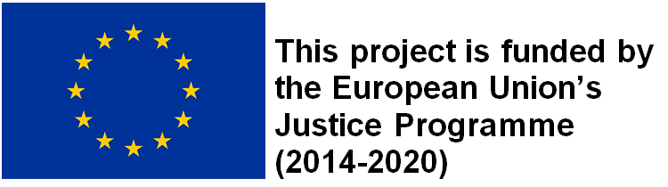
“This publication was funded by the European Union’s Justice Programme (2014-2020). The content of this training material represents only the views of the Netpralat’s Project Partners and is their sole responsibility. The European Commission does not accept any responsibility for use that may be made of the information it contains."

